KENDRIYA VIDYALAYA NABARANGPUR
CLASS- V__ SUMMATIVE ASSESMENT – II SUB : EVS
NAME : ……………………………………………… ROLL NO: ………… FULL MARKS : 60
DATE : …………………………… TIME : 2 HOURS
COMPETENCY | OBSERVATION(20) | IDENTIFICATION  (20) | DISCOVERY OF FACTS (20) | TOTAL (60)
MARKS
GRADES
OBSERVATION (20)
VSA =1X7
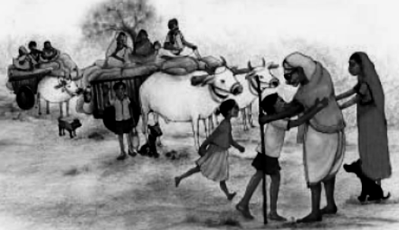
I. Observe the following pictures and answer the questions.
1. This huge group of people is called______________.

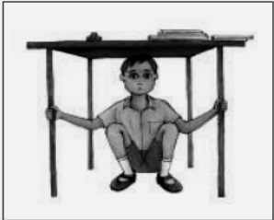
2. From which natural calamity does the boy try to save
his life?
Ans : _________________________________
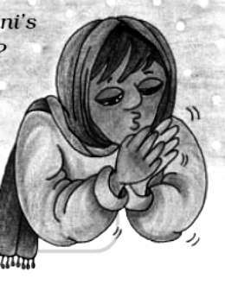
3. The girl tries to ______________ her hands by
blowing air.
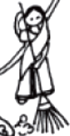
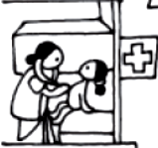
Which is the menial work ?
4. Ans : ________________________

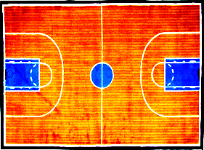
5. Name this court : ___________________________

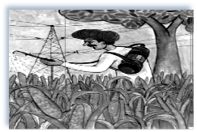
6. The farmer is spraying _______________on the crops.

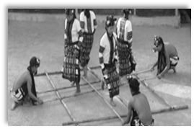
7. Name this dance :__________________________

II. Observe the following pictures and answer the questions. SA - 2X4
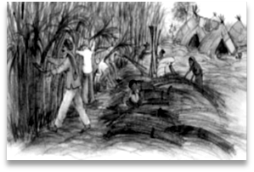
1. How do these people settle in this place ?
Ans : ___________________________________
________________________________________
________________________________________________________________________________________________________________________________

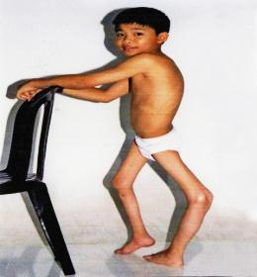
2. From which disease does this child suffer ?
Ans: ___________________________________
What steps has the Government taken to eradicate this
disease?
Ans : ___________________________________________________________
_______________________________________________________________
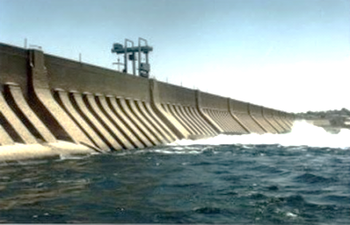
3. Name this construction : _____________________

How does its building affect the life of the people living in that area ?
Ans : _______________________________________________________
________________________________________________________________
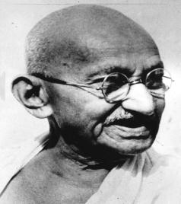
4. Name this person : ___________________________
What did he do for the low caste people ?
Ans : ______________________________________________
________________________________________________________________
LONG ANSWER (5)
III. Observe the pictures below and write the journey of the bajra seed from a field to a plate.
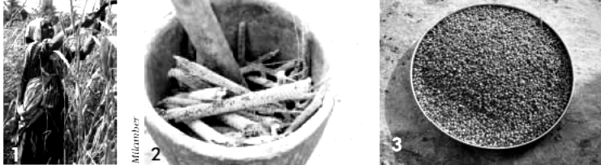
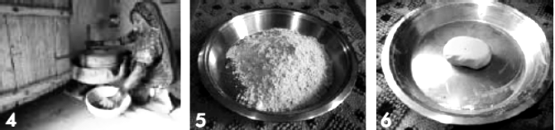

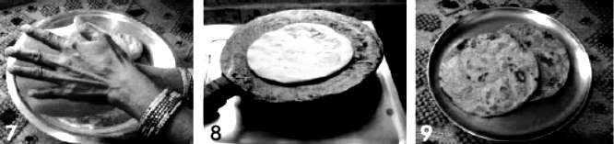

Step i. __________________________________________________________
________________________________________________________________
Step ii. __________________________________________________________
________________________________________________________________
Step iii. _________________________________________________________
________________________________________________________________
Step iv. _________________________________________________________
________________________________________________________________
Step v. _________________________________________________________
________________________________________________________________
Step vi. _________________________________________________________
________________________________________________________________
Step vii. _________________________________________________________
________________________________________________________________
Step viii. _________________________________________________________
________________________________________________________________
Step. ix. _________________________________________________________
IDENTIFICATION (20)
I. Choose the best answer and fill in the blanks. 1x5
1. Vehicles stop at the __________________ for filling fuel.
a) bus stop b) market c) petrol pump d) depot
2. You can find cold desert in ______________________.
a) Rajasthan b) Leh c) Abu Dhabi d) Tamilnadu
3. ______________ is a water related natural calamity.
a) earthquake b) forest fire c) flood d) tornado
4. ____________________ is an instrument used to listen our heartbeat.
a) microscope b) telescope c) stethoscope d) horoscope
5. _________________ disease can be inherited from parents to their children.
a) Polio b) Leprosy c) heart disease d) Malaria
II. SHORT ANSWERS 2x5
1.Classify the following games in the box into as playing as an individual and as a team.
Ludo , chess , cricket , volleyball , badminton , single title tennis , hockey , weight lifting , shooting , kho-kho , basketball , running race , boxing , baseball , kabbadi , football
Ans:
Playing as an individual | Playing as a team
2. Differentiate between
Village life | City life
3. Name 4 different harvest festivals and in which season and states of India are they celebrated . For this complete the following table.
Ans :
Harvest festival | Season | States
4. List out 4 activities for which you blow air from your mouth.
Ans : i) _________________________________________________________
ii) ______________________________________________________________
iii) _____________________________________________________________
iv) _____________________________________________________________
5. Suggest some ways to save petrol.
Ans : ___________________________________________________________
________________________________________________________________
________________________________________________________________
III. LONG ANSWER (5)
Write down the names of your family members with the following features and name the relationship between you and them.
Features | Name | Relation
i) Who is the tallest?
ii) Who is the shortest ?
iii) Who laughs the loudest ?
iv) Who speaks the loudest ?
v) Who speaks the softest ?
vi) Who has the longest hair?
vii) Who is the best cook ?
viii) Who is good at study ?
ix) Who has brown colour hair ?
x) Who is good in sports ?
DISCOVERY OF FACTS (20)
I. Choose the correct answer and fill in the blanks. VSA- 1X5
1. _________________ farming can be done when there is no rainfall. (rice / sugarcane)
2.The sea close to the state of Odisha is ___________________ . (Arabian sea / Bay of Bengal)
3. _______________ is a natural insecticide. ( rose leaves / neem leaves )
4. If there is fire in the streets, we should dial _____________ first. ( 100 / 101)
5. When we inhale , our chest ____________________ . ( contracts / expands )
II. Answer the following questions. SA – 2X5
1. Shade 8 names of the sports persons in the given grid.
A | B | H | I | N | A | V | S
U | K | A | R | N | A | M | A
S | X | S | F | M | B | D | I
H | D | H | O | N | I | K | N
A | L | S | A | N | I | A | A

2. Write 4 ways would you do so if you were to cool dal , rotis , rice etc.
Ans : ___________________________________________________________
________________________________________________________________
________________________________________________________________
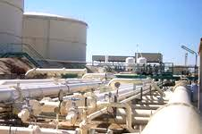
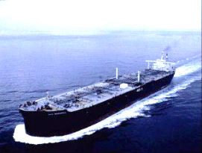
________________________________________________________________3. Mark correct arrows and write the serial numbers to show the journey of petrol .
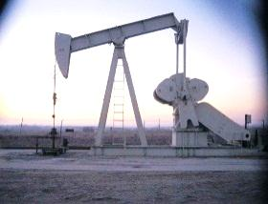

Petroleum oil Petrol Depot Transportation
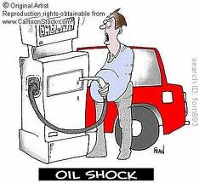
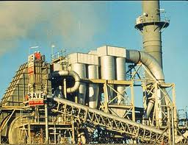

Refinery/ Processed Petrol pump
4. Draw your own family tree. ( Starting from your grandparents )

5. Mark the forests on the following India map.
Very thick forest – Dark green
Less thick forest – Light green
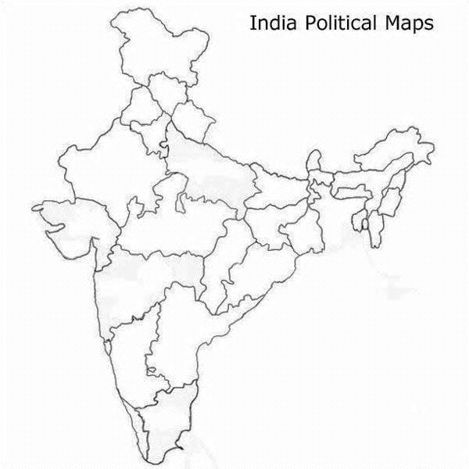

III. LONG ANSWER. (5)
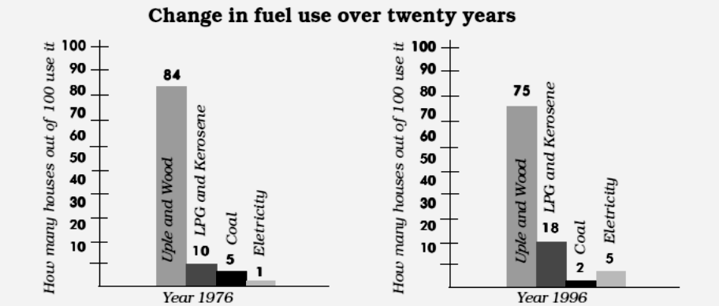
Read the bar chart carefully and answer the questions.

1. In year 1976, out of 100 how many houses used uple and wood ?
Ans : ____________________________________________________________
2. Which was the fuel used the least in 1976 ?
Ans : ____________________________________________________________
3. In 1976, LPG and kerosene were used in __________ houses and in 1996 this increased to _______________ . This means that in twenty years their use increased by _________ %.
4. Out of 100 how many houses were using electricity in 1996 ?
Ans : ____________________________________________________________
5. Which fuel was used the least in 1996 ? What percentage of houses used it in the year 1976?
Ans : ____________________________________________________________

######## THE END ##########

